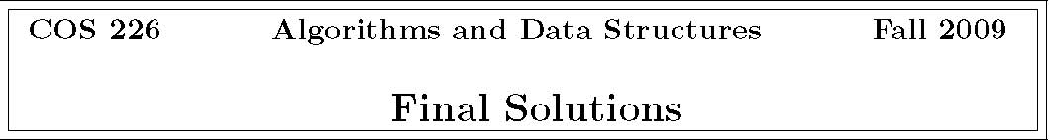
1. Analysis of algorithms.
(a) P Printing the keys in a binary search tree in ascending order. U Finding a minimum spanning tree in a weighted graph. P Finding all vertices reachable from a given source vertex in a graph. P Checking whether a digraph has a directed cycle. P Building the Knuth-Morris-Pratt DFA for a given string. P Sorting an array of strings, accessing the data solely via calls to charAt().
I Sorting an array of strings, accessing the data solely via calls to compareTo(). I Finding the closest pair of points among a set of points in the plane, accessing the data solely via calls to distanceTo().
(c) • The N3 one might be much easier to correctly implement, debug, and test.
    - The N3 algorithm might be faster for the values of N of interest (e.g., because of the leading constant).
    - The N3 algorithm might use less memory.
    - (d) 56 bytes.

(b) | A Insert into a red-black tree. | A. log N worst case
 | C Insert into a 2d-tree. | B. log N amortized
 | B Insert into a binary heap. | C. log N average case on random inputs

Each Point object consumes 32 bytes (8 bytes for each of the three double instance variables; 8 bytes of object overhead). Each Node object consumes 56 bytes (4 bytes for each of the 3 reference instance variables;
4 bytes for the int instance variable; 32 bytes for the Point3D object; 8 bytes of object overhead).
1
2. Breadth-ﬁrst search.
(a) ABCDEGFHI
(b) d

3. Minimum spanning tree.
(a) 123567812
(b) w ≤ 8
(c) 613257812
(d) Find the unique path between x and y in T . This takes O(V ) time using DFS because there are only V − 1 edges in T . We claim the edge T remains an MST if and only if w is greater than or equal to the weight of every edge on the path.
    - If any edge on the path has weight greater than w, we can decrease the weight of T by swapping the largest weight edge on the path with x-y. Thus, T does not remain an MST.
    - If w is greater than or equal to the weight of every edge on the path, then the cycle property asserts that x-y is not in some MST (because it is the largest weight edge on the cycle consisting of the path from x to y plus the edge x-y). Thus, T remains an MST.

4. Shortest paths.
(a) vertex: ACDFHEBGI
distance: 0 1 12 20 25 28 34 40 53
(b) A → C, C → D, C → B, D → F , F → H, H → E, E → G, G → I
5. Ternary search tries.
(a) ear fo his hitch hold holdup hotel hum humble ill
(b)
(c) | • faster, especially for search miss • support character-based operations such as preﬁx match (autocomplete), longest preﬁx, and wildcard match

6. Substring search.
0 |  | 1 | 2 | 3 | 4 | 5 | 6
a | 1 | 2 | 2 | 4 | 5 | 6 | 2
b | 0 | 0 | 0 | 0 | 0 | 0 | 7
c | 0 | 0 | 3 | 0 | 0 | 3 | 3

2
7. Regular expressions.
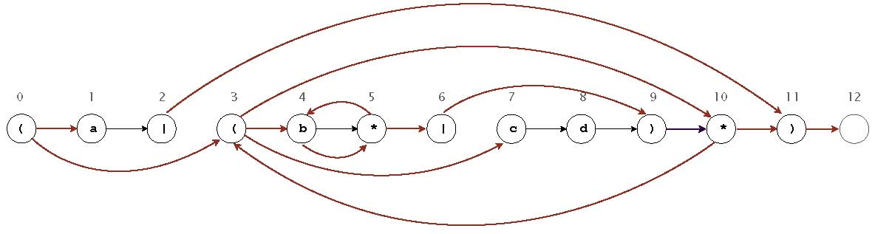
8. Burrows-Wheeler transform.
(a) 5 bbabacaa
(b) bababaaba

9. Circular suﬃxes. I only.
10. Tandem repeats.
(a) This problem is a generalization of substring search (is there at least one consecutive
copy of b within s?) so we need an algorithm that generalizes substring search. Create the Knuth-Morris-Pratt DFA for k copies of b, where k = IN/MJ. Now, simulate DFA on input s and record the largest state that it reaches. From this, we can identify the longest repeat.
(b) M+N.

11. Reductions.
(a) {−3M, x1 + M, x2 + M, . . . , xN + M }
If we can force any solution to this 4Sum instance to choose xl = −3M as one of the integers, then the remaining three integers are xi + M, xj + M, and xk + M and we have xi + xj + xk = 0.
We force any solution to this 4Sum instance to choose −3M by choosing M = 1+ max{|x1|, |x2|,..., |xN |} to be large, thereby making −3M the only negative integer.
(b) None.
3

